





**Carbon Reduction Plan 2020-2025**

1. **INTRODUCTION**

Liverpool Hope University pursues a path of excellence in scholarship and collegial life without reservation or hesitation and aims to manage its operations in ways that are environmentally sustainable, economically feasible and socially responsible. The University is committed to maintaining, and where possible, enhancing the quality of its environment for its staff and students living and working at the University; not just because we have to, but because it is embedded within our philosophy, mission and values.

The depletion of finite natural resources and the degradation of the environment presents significant risk to economic development and the quality of human life. Protecting and enhancing the quality of life for current and future generations is central to sustainability and the opportunities and challenges are considerable and dealing with these risks requires both technological invention and behavioural changes.

Reducing carbon emissions is critical to reduce, and manage, risks from increased regulation; to allow us to meet any future funding requirements; reduce the cost of the consumption of the associated products and materials; reduce operational risks associated with climate change; and improve the operation and maintenance of the estate. Carbon reduction also provides opportunities for technological advancement, personal development and enables us to contribute to a more sustainable future. As a responsible organisation, Liverpool Hope University recognises that it cannot continue to operate business as usual and sustainability and carbon reduction must form part of the core business and decision-making process. Reducing our consumption and use of goods and services and improving energy efficiency not only to reduces our carbon emissions and associated costs, but also improves our environmental impact and positions us to successfully adapt to a low carbon future.

1. **Carbon Reduction Plan purpose**

The Carbon Reduction Plan (CRP) 2020-2025 is a continuation of the 2009-2010 to 2014-2015 and draft 2015-2016 to 2019-2020 Plans and details the University’s carbon emissions, reduction targets and strategies for reducing emissions and:

* reflects changing legislation and the revision of the University’s Corporate Plan (2020 onwards)
* accounts for the evolving carbon reporting requirements and changing carbon conversion factors;
* celebrates our achievement to date;
* incorporates our current environmental position;
* allows the University to present its revised carbon reduction targets;
* details the steps required to measure, monitor and reduce its carbon emissions; and
* outlines the future carbon reduction projects and initiatives we are committed to undertake both in terms of infrastructure improvements, through stakeholder engagement and changing working practices

1. **Liverpool Hope University**

Liverpool Hope University has four campuses: there are two teaching campuses with accommodation: Hope Park, Childwall and the Creative Campus, Everton; a residential campus in Aigburth; and an outdoor recreation centre near Barmouth. The University has approximately 610 staff and 4800 student full time equivalents. The carbon emissions are calculated from an estate of over 250,000 m2 with 33 buildings and a building footprint (gross internal area) of over 85,000 m2.

Liverpool Hope University has a variety of buildings of different ages (from 1840 to present) and construction types across the four locations. Reducing carbon emissions in each of these buildings is going to require an individual approach.

1. **Connections to other strategic documents**

The CRP forms a central part of the University’s Environmental Sustainability Policy, which sets out the University’s commitment to improving its environmental impact. The Plan aligns itself with the Corporate Plan and is directly linked to the Estates Strategy and is supported by the Travel Plan, Heating Policy, Catering and Hospitality Policy, Adaptations to Climate Change Plan and Procurement Policy; and provides the pathway to how we will reduce our carbon emissions and ultimately improve our environmental impact. This Plan carries relevance and repercussions for all other University policies, strategies and plans and should be considered as they are revised.

1. **Monitoring and review**

The ongoing collection, collation and analysis of pertinent data will be undertaken by the Sustainability Manager, who will also monitor and maintain the Plan. This Plan will be revised and updated on an annual basis to ensure that we are on track to meet our ambitious targets, and to ensure that we remain agile in this ever-changing world. An annual report will be produced to reflect progress. The accompanying Carbon Reduction project plan is an active document and will be updated as projects/initiatives are completed, and as others are identified and quantified.

Progress, and any barriers, will be reported to the University’s Senior Executive Team and Estates and IT Strategic Planning Group; the minutes from which are reported to the Finance and General Purposes Committee, Senate, and ultimately University Council.

1. **Responsibility**

To achieve the carbon reduction targets set out within this Plan a whole institution approach is essential and will require commitment, conviction, skills development and the challenging of conventional approaches and behaviours. Carbon reduction has to be at the heart of how we operate and deliver our services and must become embedded in decision making processes across the full range of University operations as decisions made now and within the lifetime of this plan will dictate whether we are able to meet our carbon reduction targets. There will be some difficult choices to be made throughout the lifetime of this Plan and some opportunities may have to be re-imagined if we are to achieve our targets. The many different priorities and demands placed upon us have to be dealt with, including consideration of our budgetary constraints; it is therefore vital that we remain agile so that we can respond to all challenges.

Overall responsibility, and accountability, sits with University Council and the Office of the Vice Chancellor. The Sustainability Group, chaired by the Executive Director of Finance Services and Resources, is responsible for setting and reviewing the University’s sustainability objectives and targets and will ensure delivery of the objectives outlined within this Plan; the group will meet at least once per term.

All staff, students, visitors and business partners have an obligation to be mindful of the environment and everyone has a very important role to play in managing materials and resources responsibly and accounting for the impacts of their individual choices and actions. Everyone can make a positive contribution through promotion and practice of good environmental stewardship and working collaboratively to enable effective and enduring carbon reduction.

All members of the University community are encouraged to continue to contribute ideas and concerns to enable the fulfilment of this Plan and to actively challenge us to become more sustainable.

1. **Risk**

Failure to fully embrace the challenges and opportunities presented will lead to the creation of an unsustainable University unable to compete with its more sustainable competitors.

There are a number of high-level risks which could affect the delivery of the carbon reduction plan:

* Financial constraints linked to student numbers and funding
* Additional student numbers and/or capital projects increasing energy use and the carbon footprint
* The payback of projects being affected by energy prices
* Continued restrictions/supplies issues as a result of Brexit and Covid-19 leading to difficulties in completing projects
* Changes to building operation as a result of Covid-19
* Uncertainty how the Government and the sector will respond and engage with the carbon/sustainability agenda.

If carbon management and reduction are not embedded, the University risks:

* Increasing its consumption of goods, services and utilities (and further exposing itself to increasing costs in an increasingly volatile market);
* Increasing its carbon footprint;
* Increasing the physical risk to land and property due to higher likely incidences of extremes of weather associated with climate change, potentially disrupting our operations through loss of facilities and increasing insurance premiums
* Reducing its resilience to energy security if self-generation is not increased
* Failing to secure funding that is linked to carbon reduction
* Failing to, contribute to and, achieve local, sector and national carbon reduction targets;
* Exposing itself to the risk of noncompliance;
* Negatively impacting on the University’s Corporate profile and reputation.

1. **DRIVERS FOR CARBON REDUCTION**

The sustainability agenda has progressed rapidly over the past decade with growing recognition of the global challenges posed by issues such as climate change, reduced resource availability and population growth. There are many factors driving our need to reduce our carbon emissions, improve our environmental sustainability and reduce our negative impact overall, including:

* 1. **Global**

Public awareness and demand for climate action has been increasing and is continuing. Increasing media attention and the significant changes in the weather recently experienced all contribute to society seeing climate change as a pressing issue. The pressure on businesses to commit to a greener strategy and actively reduce their emissions is increasing.

The 2020’s has been named as the decade of deliverance for sustainability because:

* The deadline to achieve the [UN Sustainable Development Goals](https://sdgs.un.org/goals) is 2030.
* The IPCC has repeatedly warned that the coming years (to 2030) are the most crucial to cap the global temperature increase in the line with the 2015 Paris Agreement limit of below 2°C and ideally below 1.5°C
  1. **UK Government**

The UK Government declared a Climate Emergency in May 2019 and increased the greenhouse gas reduction targets set within the Climate Change Act 2008 to achieve [net zero](https://www.wri.org/blog/2019/09/what-does-net-zero-emissions-mean-6-common-questions-answered)[1] by 2050 (previously an 80% reduction from a 2009 baseline) with an interim target of 68% reduction by 2030 on a 1990 baseline. Many government bodies, local authorities and public sector bodies have also declared climate emergencies and set net zero targets.

The UK Government has also released a number of Strategies and Plans (including the draft Sustainability and Climate Change strategy for the education and children’s services systems; the Industrial Strategy; Clean Growth Strategy 2017; National Procurement Policy Statement and A Green Future: Our 25-year plan to improve the environment) which all encourage and support homes, businesses and industrial operations to minimise their carbon footprint and improve their wider environmental impact in a variety of ways. A major focus of these is embracing cleaner and greener fuels, decarbonising the electricity supply and the electrification of heat.

Other Government regulatory drivers include the EU Energy Performance of Buildings Directive; Building Regulations Part L; Climate Change Levy and other taxes and levies; and Streamlined Energy and Carbon Reporting.

* 1. **Local Government**

The Liverpool City Region declared it would achieve net zero by 2040 and Liverpool City Council by 2030.

* 1. **Sector**

**Office for Students / HEFCE**. HEFCE, the Office for Students (OfS) predecessor, saw the impact of the sector on the environment as a key responsibility and set sector carbon reduction targets (48% reduction in Scope 1 and 2 emissions by 2020 from a 2005 baseline, though each University was able to set its own reduction target). However, when the OfS was formed in 2018 they stated that measures on sustainability were not part of their statutory function and that their regulatory remit and powers did not specifically require the OfS to act to address the sector’s carbon emissions or set an emissions reduction target. However, in January 2020, they acknowledged that they should act on carbon emissions and recommended that the board agrees to support registered providers to meet the targets set by the Climate Commission (below).

The OfS also noted that ‘pressure to tackle emissions will only increase, from students and the public, as the effects of climate change became more evident’ and that as the Government had committed to net-zero by 2050 it is likely that the recent lack of political attention on Higher Education emissions would not continue.

**Climate Commission**. The Climate Commission (a partnership between the Association of Colleges, EAUC (Alliance for Sustainability Leadership in Education), Guild HE and Universities UK) was launched in November 2019, following the UK’s net-zero greenhouse gas emissions reduction target, to catalyse action to create real impact and drive change within the Sector. In January 2020, the Commission agreed its vision and mission and released a target statement detailing a clear way ahead:

* Aim for net-zero greenhouse gas emissions for Scope 1 and 2 by 2030, as per IPCC recommendations, as a minimum;
* Significant sector actions towards reducing Scope 3 emissions within this timeframe. A first step should be to understand sector scope 3 emissions and develop a framework that can be used as a basis for understanding the current baseline and establishing a meaningful target;
* Net-zero greenhouse gas emissions should be achieved no later than 2050 (or as per devolved Government target).

The Climate Commission released a FE toolkit in June 2020 and a HE toolkit in February 2021 to provide actions required within the sector to advance sustainability and reduce carbon emissions.

**Universities UK.** In April 2021, the Universities UK held roundtables exploring the adoption of the Climate Commission’s recommendations into their policy position.

**Diamond and Wakeham Review.** These reviews examine and promote efficiencies with the Higher Education Sector. Phase 2 of the Diamond Review provided an agenda and a set of high-level commitments for achieving efficiency, effectiveness and value for money i.e. making every pound of the public’s money count.

**Students Organising for Sustainability**. The SOS (Students Organising for Sustainability – NUS’s Sustainability group) released a statement of expectation in September 2020 that all UK Universities commit to achieving net zero for all Scope 1, 2 and 3 emissions by 2030. They are currently leading on a new University and Colleges reduction targets ranking.

**Student requirements**. Students are growing up in an era where sustainability and climate action is high profile and increasingly influential and they are becoming more knowledgeable and passionate about making change happen. Studies by the Higher Education Academy and the NUS have repeatedly shown that UK students want sustainability to be reflected in their institution, their studies and in their overall University experience. The 2019-2020 survey found 91% of first-year students think that Universities should actively incorporate and promote sustainability; and around 65% want to learn more about it (integrated into the curriculum rather than standalone content or courses).

**c. Internal Drivers**

Operating in a sustainable manner is a core part of the University’s Mission and Values and its Corporate Plan states that “The University will redouble its efforts to reduce the University’s carbon footprint and plan its Estates developments within an environmentally viable framework that contributes towards a sustainable future”. To improve the University’s Corporate profile and increase its profile in league tables such as People and Planet’s University ‘green’ League; continue to meet the expectations of staff and students; and improve organisational resilience, reducing reliance on externally supplied energy and reducing spend on utilities which can be more prudently spent on enhancing the student (and staff) experience.

1. **CARBON EMISSIONS**

Collecting data and calculating the associated carbon emissions[2] enables the University to understand its carbon contribution, and to measure its reduction performance as carbon saving projects/initiatives are implemented.

The University’s carbon emissions cover all residential and non-residential buildings and grounds; but excludes the houses which the University owns but rents out. All data is presented in tonnes of CO2e; CO2e is the universal unit of measurement to indicate the global warming potential of greenhouse gases[3]. The University’s carbon emissions are defined by Scopes as follows:

**Scope 1 (Direct emissions):** Emissions from activities owned or controlled by the University. Examples include emissions from combustion in owned or controlled boilers, furnaces, vehicles; emissions from chemical production in owned or controlled process equipment.

**Scope 2 (Energy indirect):** Emissions released into the atmosphere associated with the consumption of purchased electricity, heat, steam and cooling. These are indirect emissions that are a consequence of the University’s energy use, but which occur at sources we do not own or control.

**Scope 3 (Other indirect):** Emissions that are a consequence of our actions, which occur at sources which we do not own or control and which are not classed as Scope 2 emissions. Scope 3 emissions can be from activities either upstream or downstream from the University (i.e. they are another organisation’s Scope 1 and 2 emissions).

It is best practice to report on all [Scope 1, 2 and relevant Scope 3](https://www.sustainabilityexchange.ac.uk/files/briefing_paper_text_-_definition_of_reporting_scopes_1.pdf#:~:text=EAUC%20Scotland%20%E2%80%93%20The%20Alliance%20for%20Sustainability%20Leadership,and%20Scope%203%20includes%20all%20other%20indirect%20) emissions; the EAUC (The Alliance for Sustainability Leadership in Education) suggest that the following sources of emissions should be considered:

|  |  |
| --- | --- |
| Scope 1 | * Gas * Fuel used within University owned or leased vehicles * Refrigerants / Fugitive emissions |
| Scope 2 | * Electricity |
| Scope 3 | * Electricity transmission & distribution, * Electricity Well To Tank - consumption, * Electricity Well To Tank – transmission & distribution * Gas Well To Tank, * Fuel Well To Tank, * Waste disposal and recycling (including construction), * Water supply and treatment, * Business travel (including hotel night stays, University funded student placements and fieldtrips)[4], * Commuting (staff and student)[5], * Home working, * Student travel to campus at the start and end of term[6], * Supply Chain / Procurement, and * Investments |

Accurate data is required for these emissions as they cannot be considered and reduced if they are not known and any reduction targets, and progress towards them, would essentially be meaningless. While we have a solid understanding of our Scope 1 and 2 emissions, we recognise that we are in a poorer position regarding our Scope 3 emissions and that we still have to consider the relevant emission sources and then complete the necessary collection and analysis of data. This, however, is not uncommon across the sector as most organisations have started with Scope 1 and 2 emissions and are only recently starting to get a solid understanding of their Scope 3 emissions. In terms of quality, it is generally accepted that measurement of Scope 3 emissions will have a higher level of uncertainty and errors may arise during the sourcing, interpretation and conversion of data; however, it is still important to include these to fully understand the relative magnitude of key sources of emissions and prioritise reduction opportunities. It is worth noting that detailed methodology has not been developed for all Scope 3 emissions and there appears to be no standard used across the sector; therefore, at present the methodology is not robust e.g. the supply chain emissions are currently calculated on a spend basis and there are concerns about double counting emissions e.g. utility costs and travel. However, the EAUC (Alliance for Sustainability Leadership in Education) are leading workgroups who are developing, and/or revising, these methodologies and the CRP will be updated as required to reflect this.

Emissions are calculated as accurately as possible with the data that is available at the time of writing using primary data where possible (such as kWh, L and m3), then secondary data (such as distance), then spend data as a last resort using the HESCET tool.

All data reported will be for the University financial year 1 August to 31 July.

1. **CARBON PERFORMANCE (2005-2006 to 2019-2020)**
2. **Scope 1 and 2 emissions**

The University’s Scope 1 and 2 carbon emissions have reduced by 51% since 2005-2006 (Figure 1). The consumption of gas and electricity account for the majority of emissions and until 2018-2019 electricity was the dominant source; the emissions from refrigerant gases are variable but have never contributed more than 5%; and the fuel used within University owned vehicles is negligible. The electricity emissions have reduced predominately because of the reduction in carbon conversion factor (see below for more detail) as the UK has moved away from coal generated electricity to using more gas and renewables. Despite our reduction in emissions, particularly since 2012-2013, we recognise that if we are to achieve our net zero ambitions significant further work is required, particularly to reduce our reliance on gas.

The University’s complete carbon footprint can be found in Appendix A and the data source of the University’s emissions can be found in Appendix B.

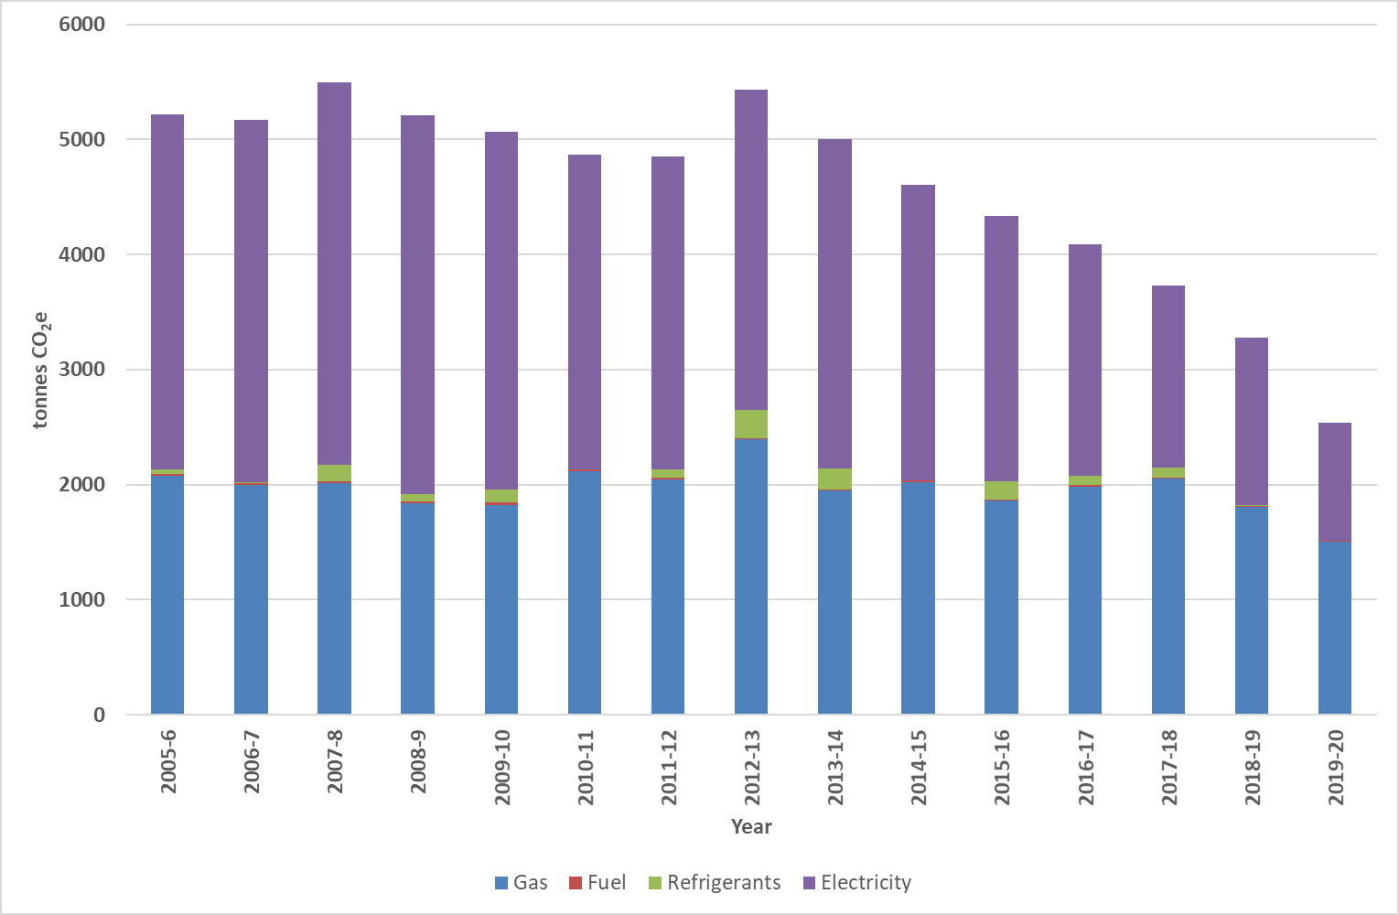

**Figure 1. Cumulative Scope 1 and 2 carbon emissions from 2005-2006 to 2019-2020**

As mentioned above it must be noted that the carbon conversion factors change on an annual basis and this can have a significant effect on the carbon tonnage from each emission source, for example, the electricity conversion factor changes dependent on the mix of fuels used to create the electricity such as coal and renewables and has decreased by 51% between 2005-2006 and 2019-2020, gas has reduced by 0.6%, petrol by 6.4% and diesel by 3.2%. This decreasing trend is likely to continue, though not at the same rate, so cannot be relied upon to assure delivery of our carbon reduction target and has therefore not been taken into consideration when developing our pathway to achieve our targets. It is worth noting that until 2009-2010 the Government carbon conversion factors did not separate out the Scope 3 element of gas and fuel (petrol and diesel).

**Consumption**. It is worth noting the reduction in consumption of the Scope 1 and 2 emissions sources over time (Table 1) has also contributed to the decreasing carbon emissions; it is not just through the change in conversion factors. Between 2005-2006 and 2019-2020 the consumption of gas has decreased by 27.3%, fuel (petrol and diesel) by 43% and electricity by 32.6%; however, it must be noted that during the pandemic (March 2020 onwards) operation and occupancy of the University has been unprecedented.

**Table 1. Scope 1 and 2 consumption data between 2005-2006 and 2019-2020**



1. **Scope 3 emissions**

Carbon emissions are not available for all emission sources since the 2005-2006 baseline because either the data was not collected and/or the carbon conversion factors or methodology were not available. Where possible, the carbon emissions have been included for as long a time period as possible, see Table 2. These emissions have a higher level of uncertainty than Scope 1 and 2 emissions as in many cases assumptions have been made to calculate the data (for example, through the reliance on estimated data, the availability of data from third parties or the extrapolation of survey data), details of which may be found in Appendix B. These emissions will be refined and become more robust over time as data is collected and methodologies are developed and therefore it is expected that the Scope 3 emissions will dramatically increase, but will provide a more complete picture of the University’s total carbon footprint. To enable our complete carbon footprint to be calculated, the University is working to collect all of the outstanding internal data and is working with its suppliers and contractors to ensure that they supply the required data.

**Table 2. Scope 3 emissions (tonnes CO2e) between 2005-2006 and 2019-2020**



nb, Business travel data has been sourced as follows– car hire data from hire company and fuel cards, grey fleet from travel and expense forms and air travel from the travel management company, other data sources have not been considered within the data shown here

nb, Other modes of travel have not been included in the business travel emissions as they are not yet comparable over the years. nb, Construction waste disposal figures are grossly underestimated as from 2015-2016 limited data has been provided by the building contractors.

1. **Total carbon footprint 2005-2006 to 2019-2020**

The University’s total carbon footprint has been variable since 2005-2006 because of the availability of Scope 3 emissions, but since 2012-2013 (when comparable data sources are available) the carbon footprint has been decreasing. However, as additional Scope 3 emissions are included, and data becomes more robust, this is liable to change; the Plan will be updated as required to reflect this.

Using the available data Scope 3 emissions accounts for the majority (~70%) of the University’s carbon footprint (Figure 2) highlighting their significance and showing us the magnitude of the task ahead to reach net zero. Procurement is the largest of the known Scope 3 emissions (68%) contributing ~50% of the total carbon emissions; this will be an important emissions source to further analyse and investigate to reduce emissions.

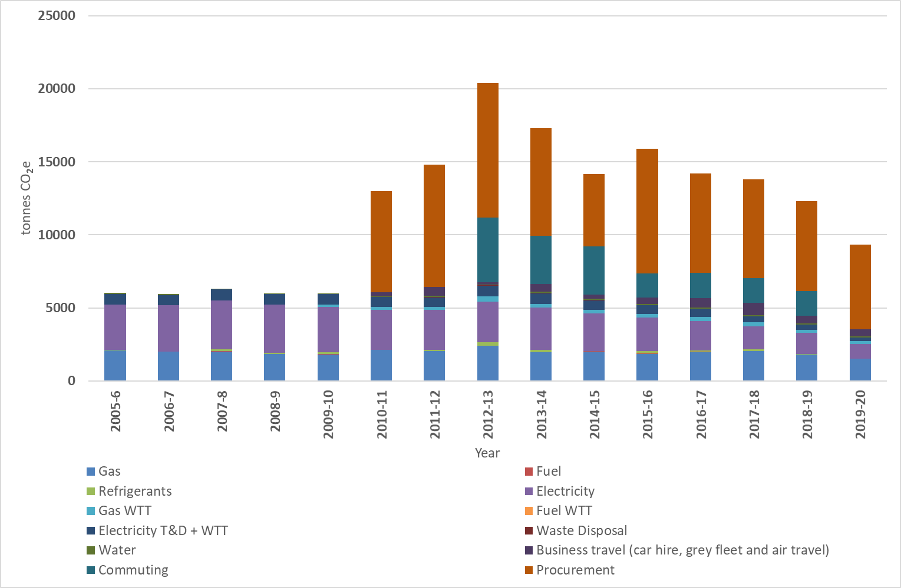

**Figure 2. Carbon footprint (Scope 1, 2 and 3 emissions) between 2005-2006 and 2019-2020**

1. **Carbon reduction projects**

To reduce our consumption and carbon emissions between 2005-2006 and 2019-2020 we identified, quantified and implemented many carbon reduction projects. These projects were predominately aimed at reducing Scope 1 and 2 emissions (focussing on gas and electricity) and include technological projects and awareness and engagement activities; of particular note are:

* Installation of gas and electricity sub and automatic meter reads across campus enabling reliable and accurate building specific consumption data on a building by building level across most of the building portfolio (gas meters cover ~54% of total consumption and electricity meters cover ~60% of total consumption). This enables usage to be analysed (how, when and where) to identify any wastage (i.e. out of hours consumption) and strategically target programs of work (such as prioritising projects in the highest consuming buildings); it also allows us to track and report on installed carbon reduction projects. The University is continuing to identify locations to improve our metering infrastructure.
* Installation and continued fine-tuning of the Building Management System across campus and linking the controls to a central location to enable the optimisation of heating and hot water settings
* Rolling programme of LED and control installation
* Boiler replacements with energy efficient models, installation of TRVs and decentralising where possible
* Heating Policy published setting out the heating and comfort expectations
* Consolidated evening and weekend teaching into the most efficient buildings
* Internal waste and recycling bins throughout the campus
* Increased the number of covered cycle shelters across campus
* The University launched the NUS’s Green Impact and Student Switch Off challenge in 2012-2013 but brought the challenges in house in 2016-2017 as the I ♥ My Campus Challenge. The schemes are staff and student competitions to complete actions across the sustainability key impact areas (identified within the Environmental Sustainability Policy) and be rewarded for their actions.

1. **CARBON REDUCTION TARGETS**

Carbon reduction targets have been set to ensure that we comply with national, international and sector commitments, contribute to a more sustainable future and improve our environmental impact as set out within the University’s strategic plans, fulfil stakeholder expectations and stay true to the University’s philosophy, mission and values. The University has set a clear and ambitious carbon reduction target to achieve net zero by:

**2040 (Scope 1 and 2 emissions)**

**and**

**2050 (Scope 3 emissions)**

The Scope 3 emission target date will be reviewed once we have collected and analysed all the relevant data and we know the full extent of our emissions. These reduction targets are absolute targets i.e. they are not relative to metrics such as FTE, GIA or turnover; though these are monitored and used to assess the performance of the University within the annual financial statements.

Dependence on the emission sources is unavoidable and the challenge is to maintain, and where possible increase, the level of progress already achieved in reducing carbon emissions. This will require a continuous review of operational policies and procedures; investment in carbon reduction projects (section 6); financial and staff resources; and awareness raising and engagement with the University community.

1. **Carbon Reduction Target 2020-2025**

**25% reduction by 2025 (Scope 1 and 2)**

To progress towards net zero a five-year interim target of a 25% reduction has been set from the 2019-2020 baseline (2535 tonnes CO2e) to 2024-2025 (1910 tonnes CO2e) i.e. a reduction of 634 CO2e tonnes. An interim target has not been set for Scope 3 as the full extent of emissions is not yet known.

1. **CARBON REDUCTION PROJECTS**

Despite the changes and projects that we have implemented in the past (saving both carbon and money) there is still much to do. The challenge is to continue to identify, quantify and implement carbon reduction projects across all areas of the estates and University community to enable the University to reduce its Scope 1 and 2 emissions to net zero by 2040 and continue its Scope 3 reduction journey aiming for net zero by 2050 at the latest. We need to make major changes to the way we work, and we can reduce our carbon footprint by continuing to embed carbon reduction and sustainability into all University processes, practices, policies and procedures; investment in carbon reduction projects; allocation of financial and staff resources; and increasing awareness and engagement with the University community, including into all roles and induction programmes. However, as always, we need to ensure that our business operations, health and safety, user requirements and expectations, and legislation/regulations are not compromised as far as reasonably practicable. Our journey will fall into four main paths:

1. Avoiding and eliminating waste - through increased awareness and engagement, such as switching off; estate rationalisation to achieve higher space utilisation rates; passive features such as insulation, solar gain and shading; reducing the amount purchased and only undertaking essential travel
2. Reducing what can’t be eliminated – redevelop buildings to the highest environmental standards of environmental performance including as installing energy efficient equipment, LEDs, and low flow showers
3. Self-generation or the installation of other low carbon assets, such as solar PV, solar thermal, battery storage, Air Source Heat Pumps
4. [Offsett](https://www.eauc.org.uk/sector_briefing_what_is_carbon_offsetting)ing – there will always be some emissions that can’t be removed, but offsetting (such as tree planting, land use and management and carbon capture and storage), will be seen as an absolute last resort and only for those Scope 3 emissions which cannot be eliminated[7]. An accepted method of offsetting has not yet been approved; the indirect nature of offsetting and reliance on third party investment makes them difficult to verify and this has led to controversy (both financial and ethical). Any offsets need to be made using robust certification standards. The EAUC recently launched the Climate Coalition, a sector wide initiative, to facilitate offsetting for FEIs and HEIs using their collective purchasing power and providing robust and credible offset projects, support and driving the demand for permanent carbon capture and storage. It would not be cost effective nor ethical to offset all the emissions and continue to consume as before.

The high-level projects identified within this plan (Table 3) will reduce consumption and therefore emissions, costs, improve efficiency and performance and embed positive behaviours; however, this list is by no means exhaustive and will be updated as further projects are identified. All projects will be subject to ongoing refinement and assessment to ensure that they are financially, operationally and sustainably feasibly; some may not be feasible and alternatives developed. The cost and carbon savings can be immediately identified for some projects, but for others a full scoping exercise is required. A full breakdown of the projects on a building-by-building, technology-by-technology basis can be found in the Carbon Reduction project plan. It is recognised that both short- and long-term projects and significant investment will be required to ensure that we meet out net zero targets.

**Table 3. Summary of carbon reduction projects**

|  |  |  |
| --- | --- | --- |
| **Scope** | **Emission Source** | **Project** |
| 1,3 | Gas | * Low carbon heating and hot water sources – ASHP, Electric panel heaters, hybrid systems, hydrogen * Boiler plant appraisal – age, efficiency to determine feasibility of transfer to low carbon heating/hot water * Heating/Boiler controls including VSD and TRVs * Building Management System – extend to cover the outstanding boilers and continue to fine-tune * Fabric first approach, including   + Insulation (boiler plant, loft void, walls)   + Replacement roof with increased insulation   + Double glazing   + Secondary glazing * Electrification of catering appliances * AMR/heat meters in outstanding buildings * Space Management |
| 1,3 | Fuel – vehicles | * Electric vehicles * Electric gardening equipment * Essential travel only |
| 1,3 | Refrigerants/Fugitive | * Low GWP HVAC systems * Replacement with heating system and openable windows * Increase passive cooling * VSD * Controls – PIRs, sensors, over-run controls |
| 2, 3 | Electricity | * Switch Off * High efficiency equipment and appliances * LED lighting and controls * ITS including controls on printers and projectors * Self-generation * AMR in outstanding buildings * Space Management |
| 3 | Waste & Recycling | * Waste hierarchy * Provision of accurate data for all waste streams * Building contractors to provide data * Waste audits |
| 3 | Water Supply & Treatment | * Completion of non-concussive taps * Completion of waterless urinal conversion * Low flow showers * Best practice flow kitchen taps * Cistern volume reduction * AMR |
| 3 | Business Travel | * Collate outstanding business travel data * Promote use of Travel Management Company for travel booking * Work to ensure travel claims provide the required information * Agree travel protocols * Promote essential only travel |
| 3 | Commuting | * Survey to determine travel methods * Promote alternative modes to single car use |
| 3 | Home Working | * Determine whether relevant |
| 3 | Student Travel to & from University | * Survey to determine travel methods |
| 3 | Procurement | * Promotion of essential purchases only and use Value for Money Principles * Ensure suppliers are correctly coded within the University’s finance system * Interrogate HESCET tool to check if double counting emissions |
| 3 | Investment | * Investigate data source and methodologies |
| ALL |  | * Improve staff and student awareness and engagement   + Sustainability website, social media, internal communications (including inductions and student guides) and events   + Promote sustainability as part of the Health and Wellbeing initiative and the I ♥ My Colleagues campaign * Develop the Sustainability Group to include a wider group of academic and support departments and students * Audits to determine baseline, progress and outstanding items * Incorporate low carbon building design principles |

These projects will be prioritised on the basis of carbon reduction, cost and payback period, and will be phased to ensure that the ‘quick wins’ are implemented first; however, the priority of these projects are subject to change dependent on University priorities, future estate development plans and available finances. The continued installation of gas and electricity sub-metering will be critical to enable the projects to be more effectively prioritised to focus on those buildings with a high consumption.

The evolving nature of the Plan and the Estate means that not all the identified projects will be implemented within the lifetime of the Plan and projects will be completed which have not been identified as priorities change, buildings are refurbished and funding becomes available.

The University has recently published it Estates Strategy (2020 to 2025) which outlines the future development and direction of the University estate and undertakes regular (five yearly) building condition and functional suitability surveys; these feed into the Estates capital, minor works and general maintenance project lists. The implementation of these projects will have both a negative and positive impact on the University’s carbon emissions and wider sustainability performance, which needs to be acknowledged. It is essential that the adoption of sustainable construction and refurbishment methods and low carbon technologies within the planned developments form an important and integral part of the Carbon Reduction Plan and will be key in delivering our carbon reduction targets.

1. **RESOURCES**

The projects will be funded through various estates budgets (general maintenance, minor works and capital projects) and specific business cases will be submitted to the University as required; other funding streams will also be investigated. Given the financial uncertainty of the future, the University will prioritise the projects and initiatives in the most cost- and carbon- effective manner as possible to provide best value for money and increase in efficiencies; and ensure a return on investment. All the projects involve staff time to ensure success, either time spent identifying and quantifying the projects, or implementing them. The need to invest sooner rather than later is acknowledged especially with rising energy costs and increased budgetary pressures, securing costs savings, improving operational efficiencies and delivering value for money.

The University’s carbon reduction and sustainability objectives and targets can only be fully realised by putting sustainability at the heart of our decision making and operational processes. Ongoing senior management support, staff and student engagement, and embedding environmental sustainability into all University operations and decision-making processes will be essential.

This Plan will not only ensure we achieve our reduction targets, but also will result in a financial savings as energy, water and waste costs are expected to continue to rise; will realised significant improvements in the operation and maintenance of the estate; and will positively support the implementation of our broader Policy to embed sustainability across the University.

1. **CARBON REDUCTION 2020+**

We can only plan and deal with the knowns today (including legislation and technology). There are many moving parts and many unanswered questions, if, buts and maybes and our plans and strategies will need to remain flexible and be adjusted as new legislation/guidelines are published, as emerging technologies become more readily available and cost effective, and as new technologies are created. We need to start making changes and acting now, despite the many unknowns.

Scope 1 and 2 should be our priority, but all scopes and emission sources offer different opportunities to cut carbon. The full commitment of senior management, and the required investment, is required to drive our net zero agenda forward. Achieving net zero emissions will be an enormous challenge (but not insurmountable), requiring a major mind shift and some difficult decisions to be made and there will be substantial costs involved. It must not be underestimated, or underdiscussed. There will also be positive benefits, for the environment, attracting and retaining staff and students, offering a more attractive proposition to investors, enhanced credibility and brand reputation, create a competitive advantage, increased resilience given likely future regulation and legislation, and future proofing the University.

Currently, the only legally binding target is the Government’s net zero greenhouse gases by 2050; but in order for the Government to reach its target it is likely that regulations and legislation will increase; and with the OfS taking a greater interest in sustainability within institutions it is likely that sector guidelines / targets will be introduced.

|  |  |  |  |  |
| --- | --- | --- | --- | --- |
|  | **Version** | **Date** | **Details** | **Issued by** |
| **Approved by USET** | 1 | 22/11/2021 | Original document | Suzanne Moody |
|  |  |  |  |  |
|  |  |  | **Review date:** | 22/11/2022 |

**Appendix A. Carbon footprint (tonnes CO2e)**



**Appendix B. Data sources**

|  |  |  |  |  |
| --- | --- | --- | --- | --- |
| **Scope** | **Emissions Source** | **Source** | **Details** | **Accurate / Estimated** |
| 1 | Gas (consumption) | Utility invoices supported by monthly meter reads |  | Accurate |
| 1 | Fuel used within University owned vehicles | Fuel card (petrol and diesel) |  | Accurate |
| 1 | Refrigerants / Fugitive emissions | F-gas register |  | Accurate |
| 2 | Electricity (consumption) | Utility invoices supported by monthly meter reads |  | Accurate |
| 3 | Electricity transmission & distribution | Utility invoices supported by monthly meter reads |  | Accurate |
| 3 | Electricity Well To Tank (consumption) | Utility invoices supported by monthly meter reads |  | Accurate |
|  | Electricity Well To Tank (T&D) | Utility invoices supported by monthly meter reads |  | Accurate |
| 3 | Gas Well To Tank | Utility invoices supported by monthly meter reads |  | Accurate |
| 3 | Fuel Well To Tank | Fuel card (petrol & diesel) |  | Accurate |
| 3 | Waste disposal and recycling | Contractor reports | Variable depending whether weight data is accurate (2010-2011 & 2012-2013) or estimated. Estimate breakdown of DMR | Estimated |
|  | Waste disposal & recycling (construction) | Contractor reports (including general University skip data) | From 2015-2016 limited data provided by building contractors | Estimated |
| 3 | Water supply & treatment | Utility invoices, supported by monthly meter reads | United Utilities assumes wastewater is 100% of water consumed | Accurate |
| 3 | Business travel | 1. Travel Management Company[8] 2. Credit Card 3. Expenses 4. Car Hire company 5. Fuel cards | Assumptions are made. Where distances cannot be calculated emissions are calculated using spend (HESCET tool) | Estimated |
| 3 | Business travel – hotel stays | 1. Travel Management Company 2. Credit card company 3. Expenses |  | No data |
| 3 | Business Travel – Student Placements & Fieldtrips[9] | School and Department information |  | No data |
| 3 | Staff & Student Commuting | Survey[10] |  | Estimated |
| 3 | Homeworking | TBC |  | No data |
| 3 | Student travel to campus at the start & end of term | Survey |  | No data |
| 3 | Supply Chain / Procurement[11] | Higher Education Supply-Chain Emissions Tool (HESCET) | * Based on spend (Proc HE coding) * Possible double counting of emissions | Estimated |
| 3 | Investments | TBC |  | No data |

1. **‘Net zero’** refers to achieving an overall balance between emissions produced and emissions taken out of the atmosphere. Principally, we have to reduce emissions to an absolute minimum and then offset any remaining emissions (tree planting, land use and management, carbon capture and storage). An accepted method of offsetting has not yet been approved, but there has been discussion between the Students Organising for Sustainability (the sustainability branch of the NUS) and Universities to explore what this might look like.
2. Carbon emissions are calculated using the Government’s conversion factors for company reporting <https://www.gov.uk/government/collections/government-conversion-factors-for-company-reporting#conversion-factors-2016>
3. There are seven main greenhouse gases that contribute to climate change, as covered by the Kyoto protocol – carbon dioxide (CO2), methane (CH4), nitrous oxide (N2O), hydrofluorocarbons (HFCs), perfluorocarbons (PFCs), sulphur hexafluoride (SF6) and nitrogen trifluoride (NF3)
4. Scope 3 travel and transport emissions are widely recognised as one of the most challenging sources of emissions to calculate
5. The University has very little scope to dictate / influence how staff and students travel to University as it is their personal decision; however, measures can be put in place to influence travel and behaviour
6. Student travel to the University at the start and end of term is out of our control and sphere of influence and the University does not currently have effective, efficient and accurate data capture mechanisms in place (to collect either the mode of transport, distance travelled or the number of times the students travel home); though emissions may be significant. Student travel also raises the question of whether travel to graduation should be included.
7. The Carbon Reduction Target and Strategy for HE in England 2009 states: Carbon offsetting may not be used to meet institutions carbon reduction targets for Scope 1 and 2 emissions. However, carbon offsetting may form part of the institutions Carbon Management Plan
8. Air travel – from 2019-2020 return long haul flights (over 3700km) have been separated into those departing from UK airports and those departing from non-UK airports
9. Only travel which is paid for by the University will be included
10. The data is extrapolated from the responses received from biennial travel surveys and is based on a number of assumptions.
11. ‘sector average’ carbon intensity values are used, meaning they do not reflect ‘local’ differences in consumption, such as consumption of eco-friendly products which often have a higher price. Comparison between years is problematic as the methodology drastically changed for the 2018-2019 data set and data must be treated with caution. However, across the sector HESCET is the best available tool at present